
[Put a provocative and discipline-specific question here that is open ended.]

Know the answer?, No?, ask me a question (suggestions below).
- Suggestion 1?
- Suggestion 2?
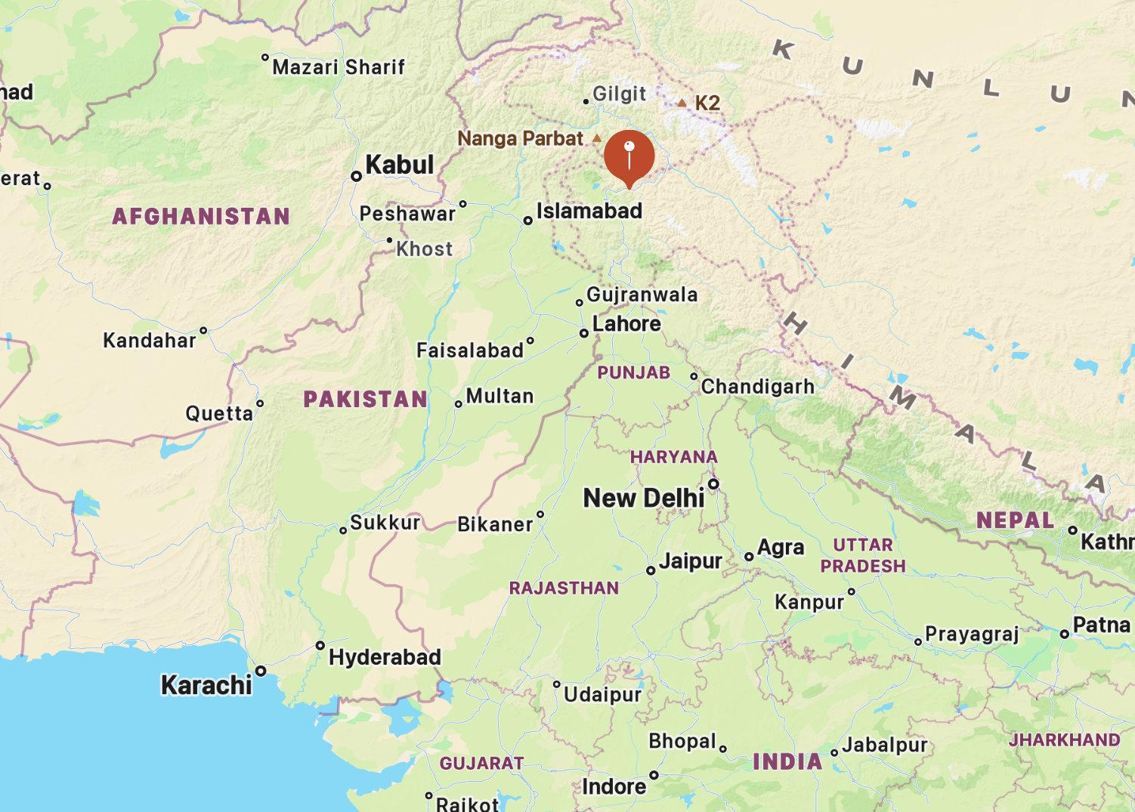Figure 1: https://duckduckgo.com/?q=pahalgam+kashmir+map&t=ffab&iaxm=maps&source=about
- Suggestion 3 ?
Add your own image here.
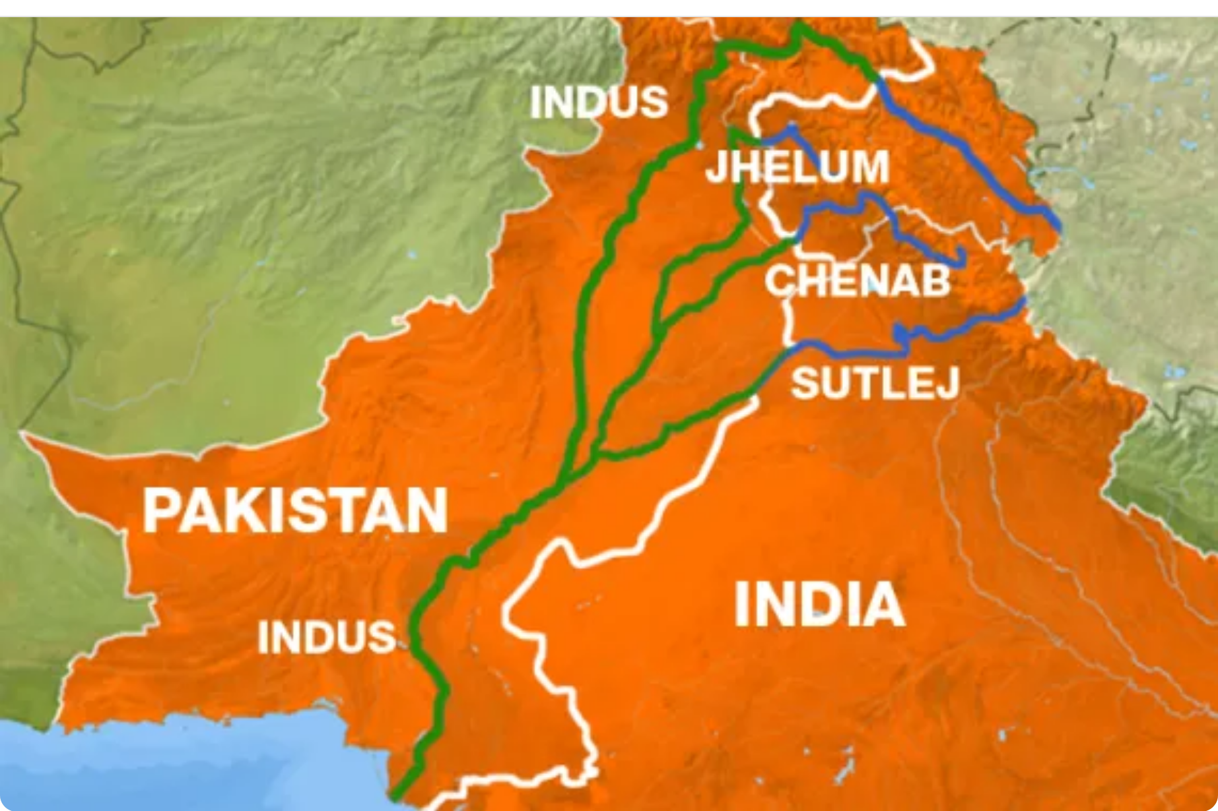Figure 2: https://www.aljazeera.com/news/2011/8/1/kashmir-and-the-politics-of-water.
Add your own images here.

- More questions
- More questions
- More questions?

Sources:
All images used under Academic Fair Use Copyright

[Submit to Marketing Dept (Mary Solverson) with your department code for printing on poster-size board. Glue to poster board and borrow easels from Kopp Student Center or elsewhere. Stand in next to poster and invite questions.]

