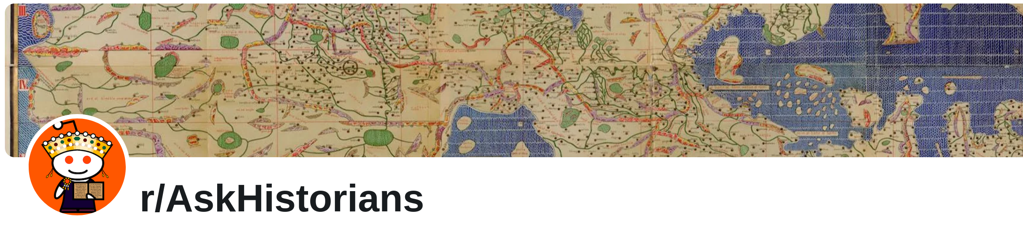
Why did India cut off the Indus river from Pakistan last week?

Know the answer?, No?, ask me a question (suggestions below).

- What were the immediate causes of shutting off the river?
- Where is Pahalgam?
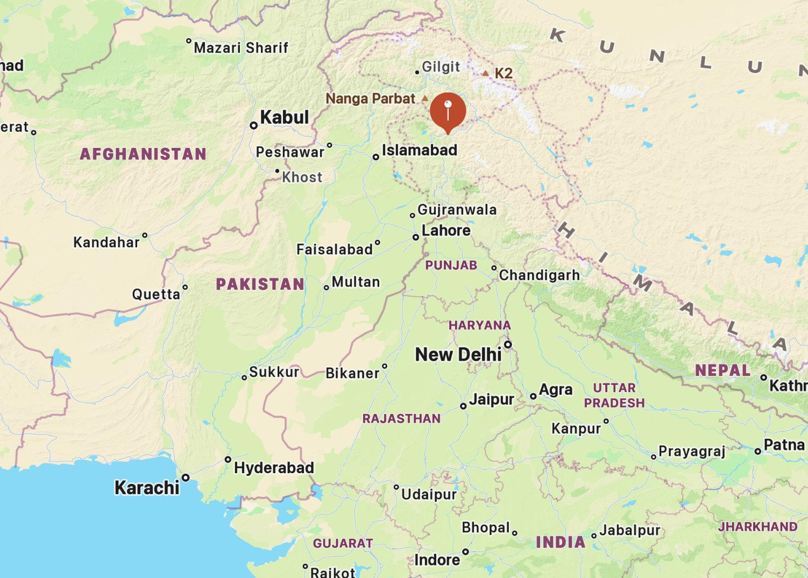Figure 1: https://duckduckgo.com/?q=pahalgam+kashmir+map&t=ffab&iaxm=maps&source=about
- What river rights are in dispute?
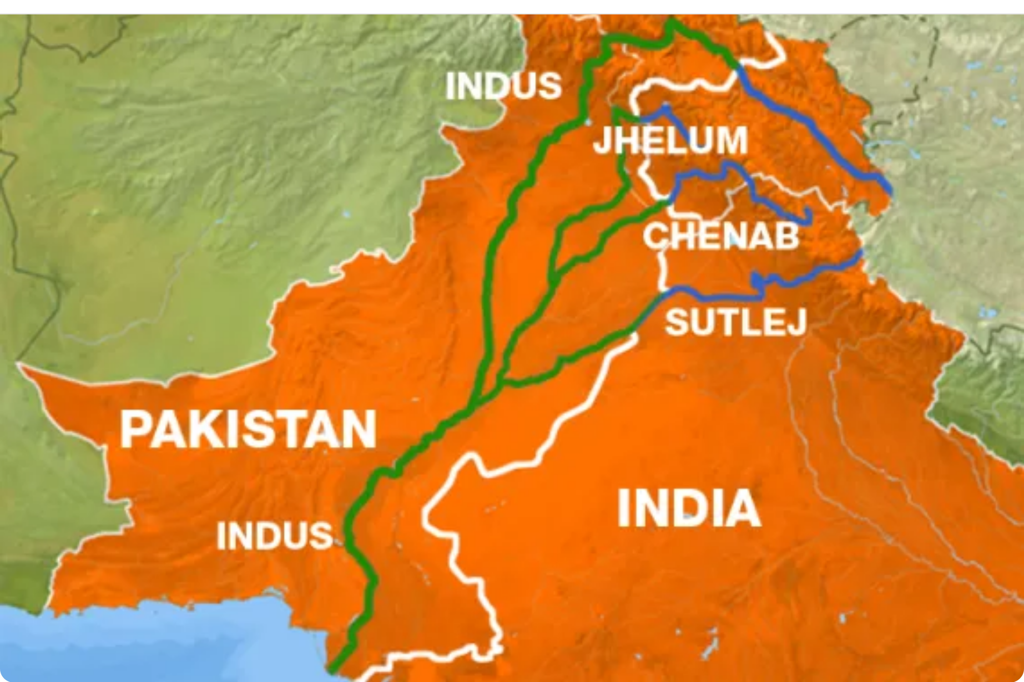Figure 2: https://www.aljazeera.com/news/2011/8/1/kashmir-and-the-politics-of-water.

- What is this history of these two countries?
- What is happening right now?
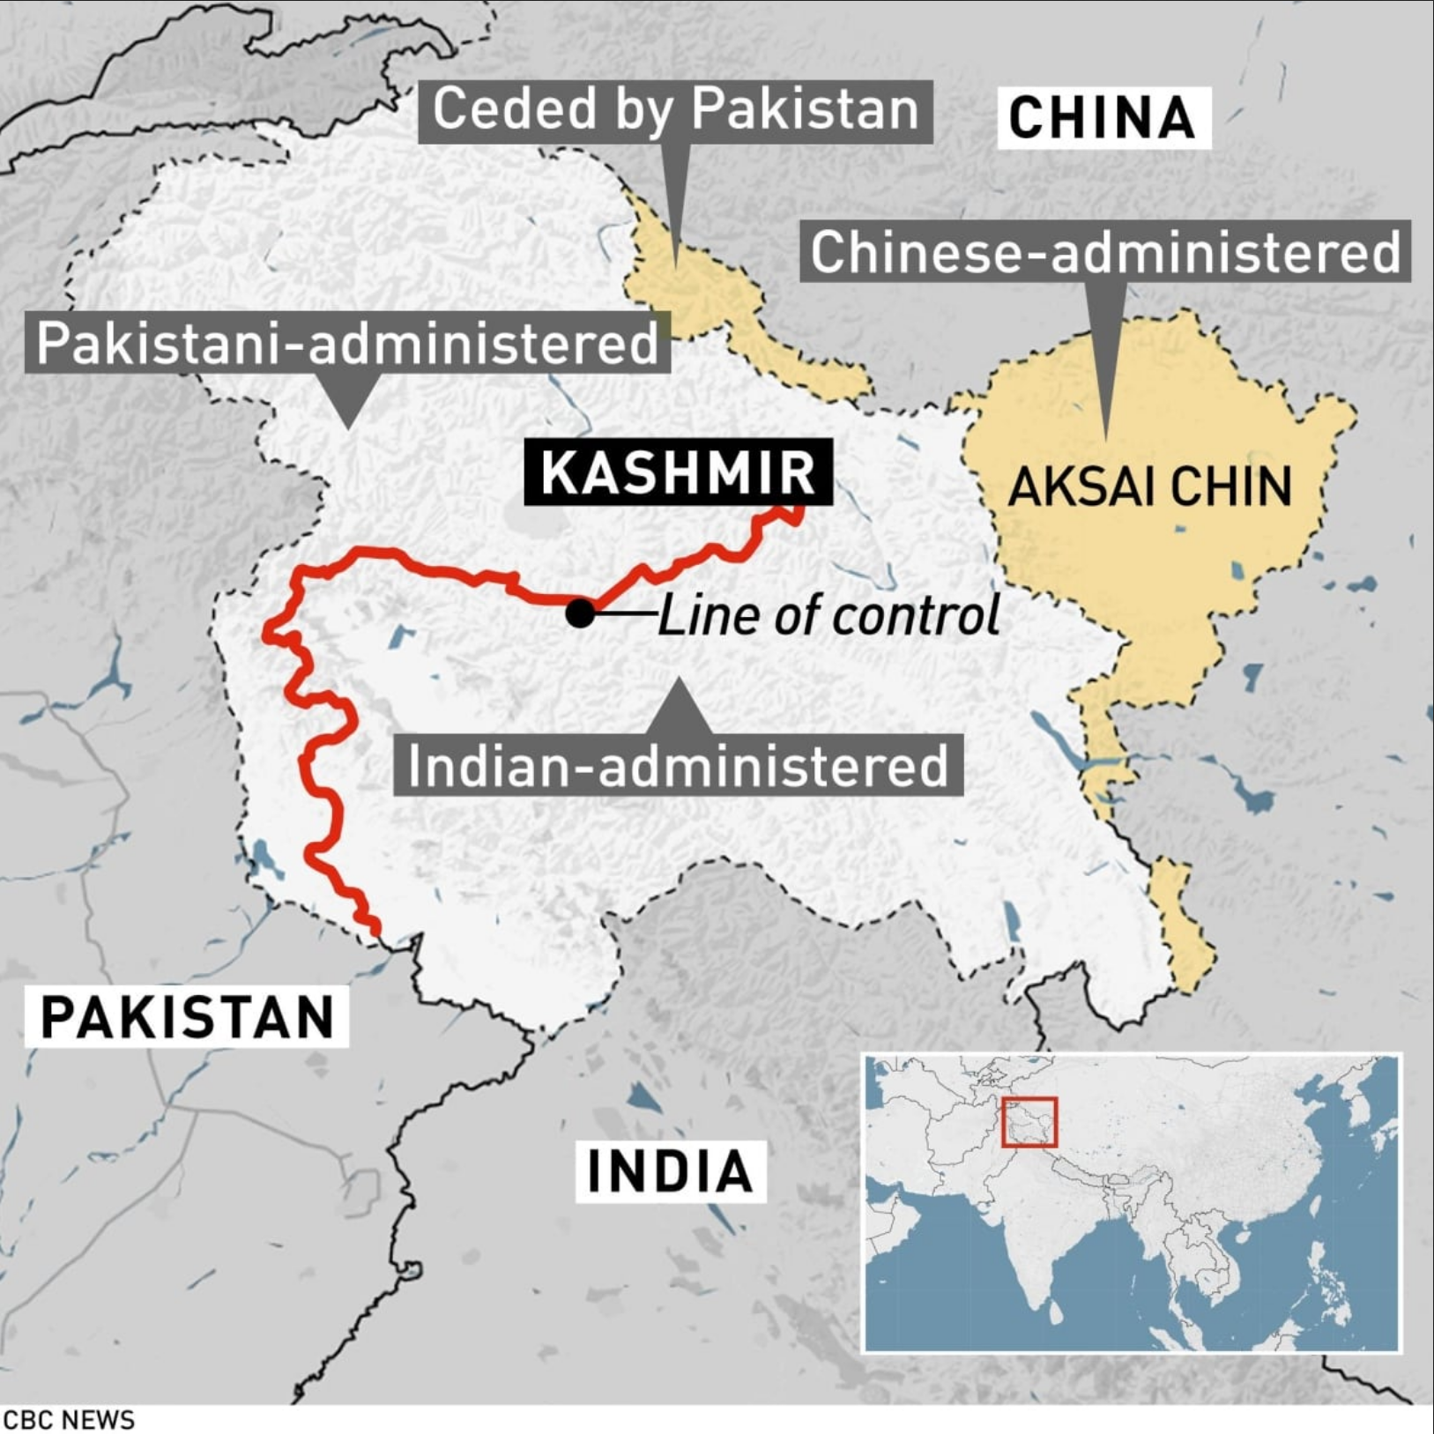Figure 3: https://www.cbc.ca/news/world/india-pakistan-violence-kashmir-1.5035720
- Is this serious?
- What is the Line of Control?

Sources: Al Jazeera. “Kashmir and the Politics of Water.” Accessed April 28, 2025. https://www.aljazeera.com/news/2011/8/1/kashmir-and-the-politics-of-water.
Standish, Reid, and Daud Khattak. “India And Pakistan Are On The Brink Of Conflict. Here’s Why.” Radio Free Europe/Radio Liberty, April 28, 2025, sec. Pakistan. https://www.rferl.org/a/india-pakistan-war-nuclear-kashmir-modi-water-treaty/33396913.html.

All images used under Academic Fair Use Copyright

