Indus River and Flood History

Learning Goals.
After this lesson, you should be able to identify major causes of floods along the Indus, evaluate historical maps of floods, and articulate the major issues nations face in responding to floods.

Warmup
How do rivers shape your everyday life? Write three ways below.
1.
2.
3.

Key Vocabulary Terms

- Riparian Rights
- Prior Appropriation
- Dam
- India
- Pakistan
- Inundation Canals
- Perennial Canals
- Embankments
- Barrages
- Indus River

Use the video to define the terms above
https://youtu.be/3bVGuXrd5mg?si=k1FzZZLf3-uNTBn6

For the following four sources (one text, two maps, one data table), write one question you would ask the creator of the source to better understand it. Write an X next to anything that you find interesting.

Source 1:
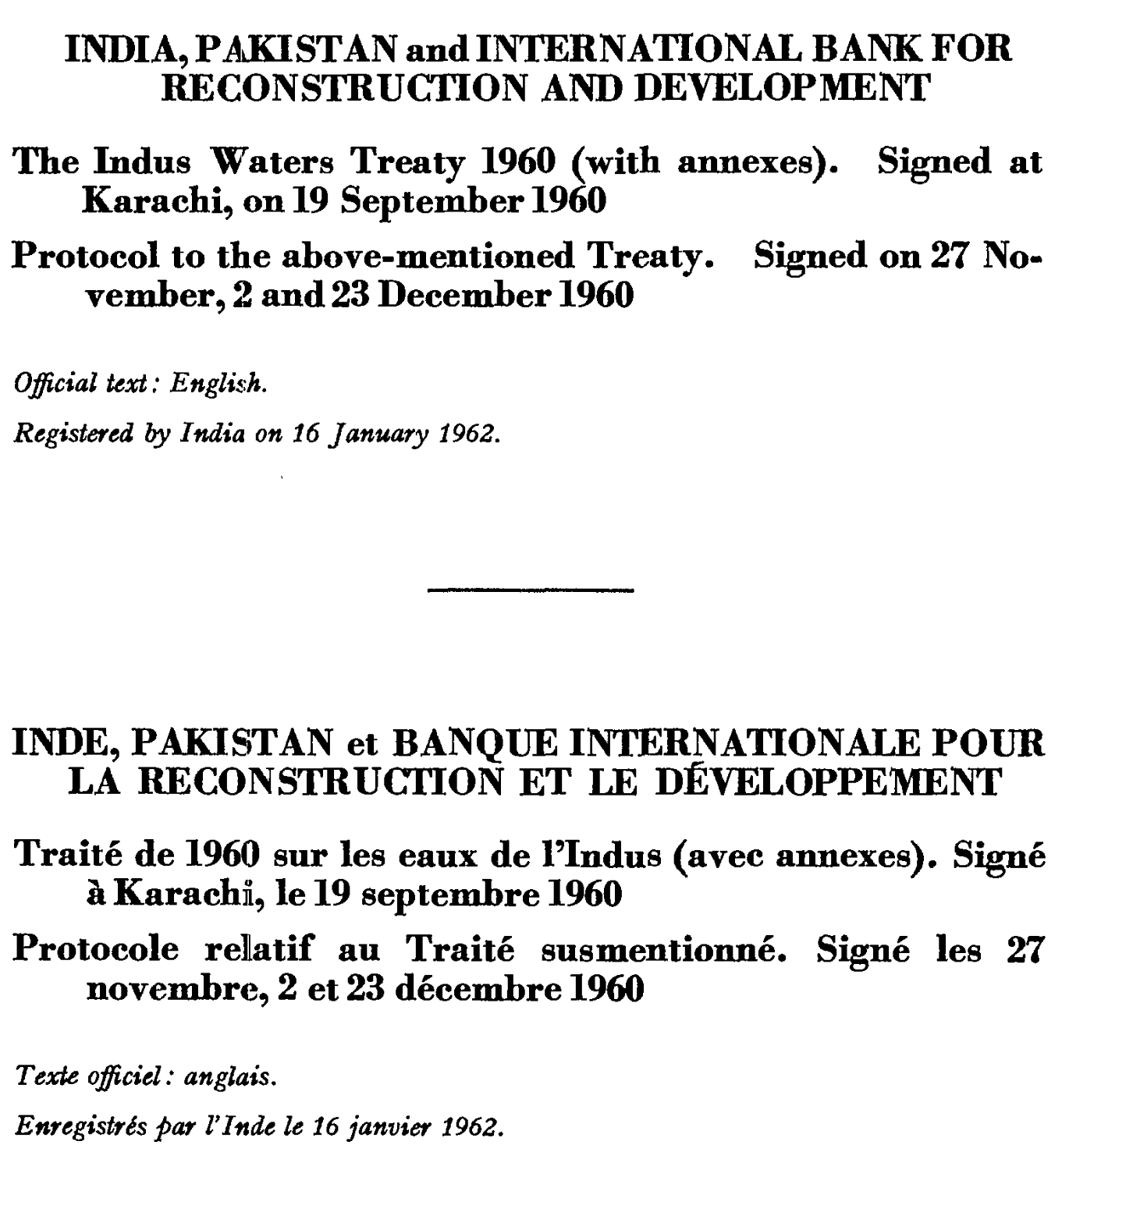

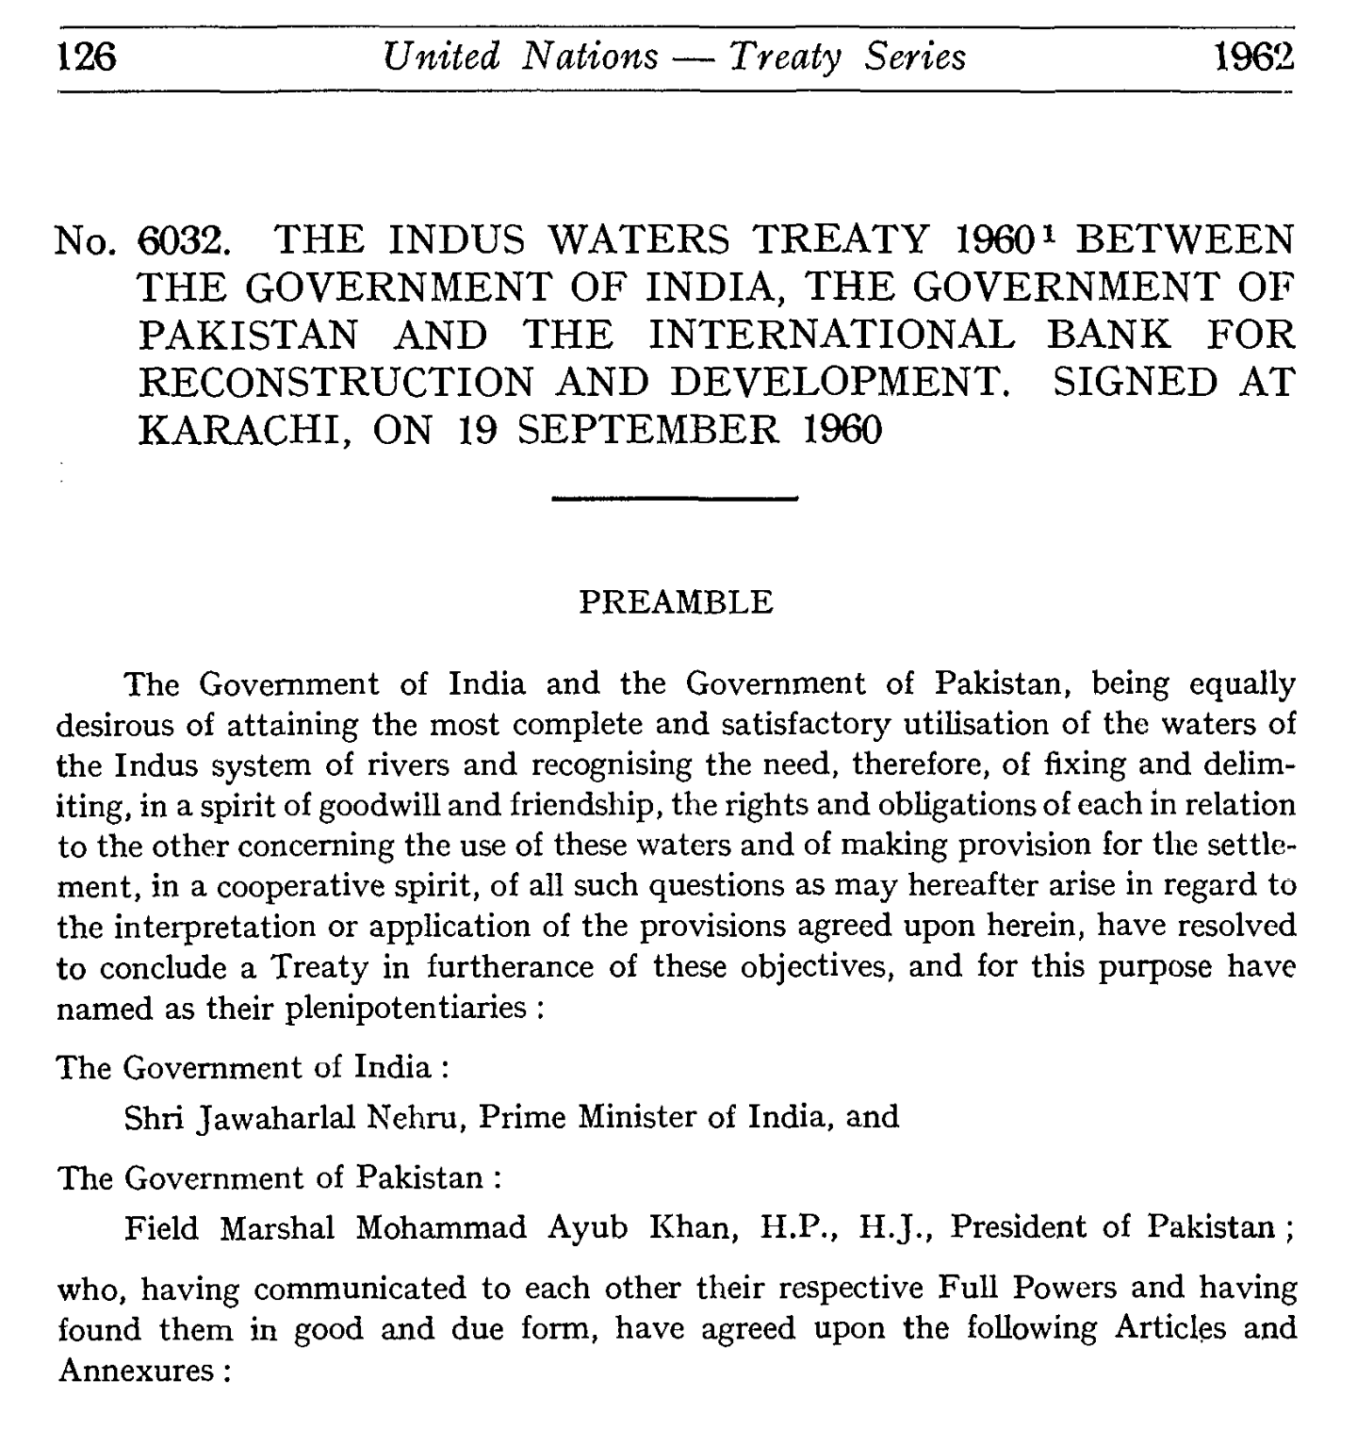
Sources 2 and 3: NASA Maps of 2010 Floods along the Indus River Valley

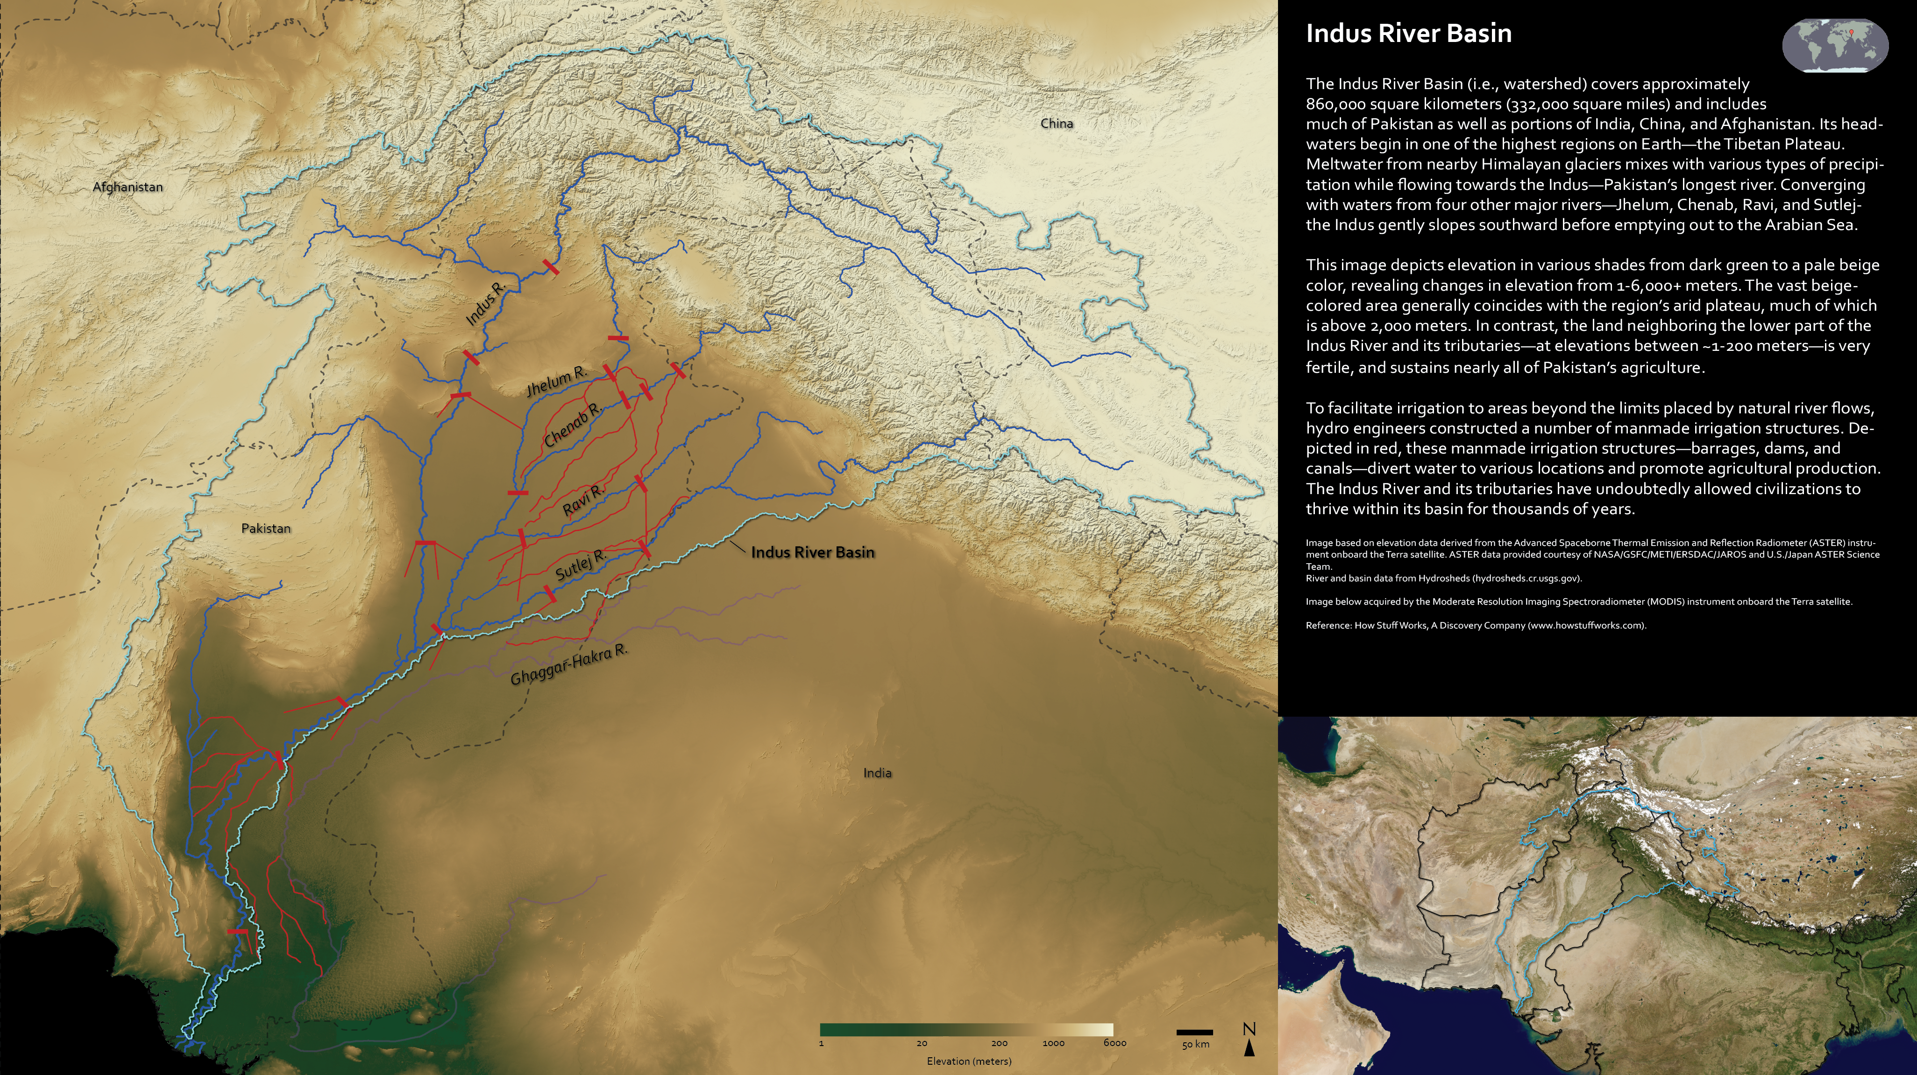

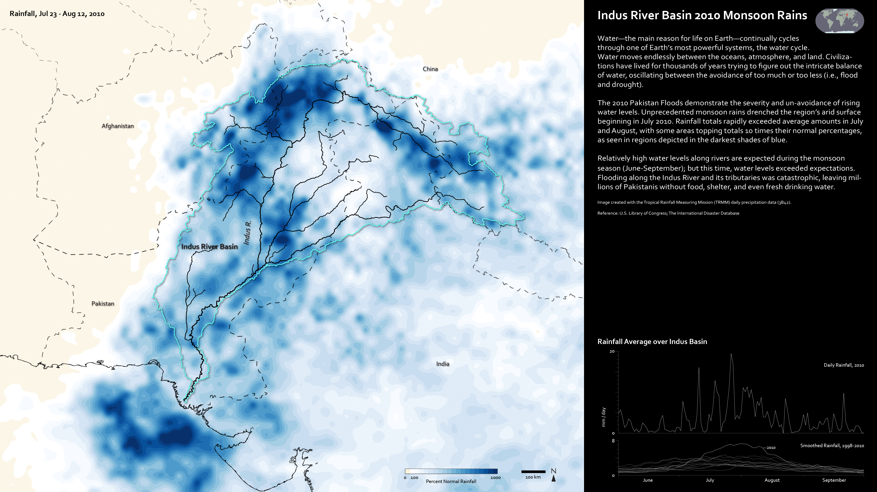

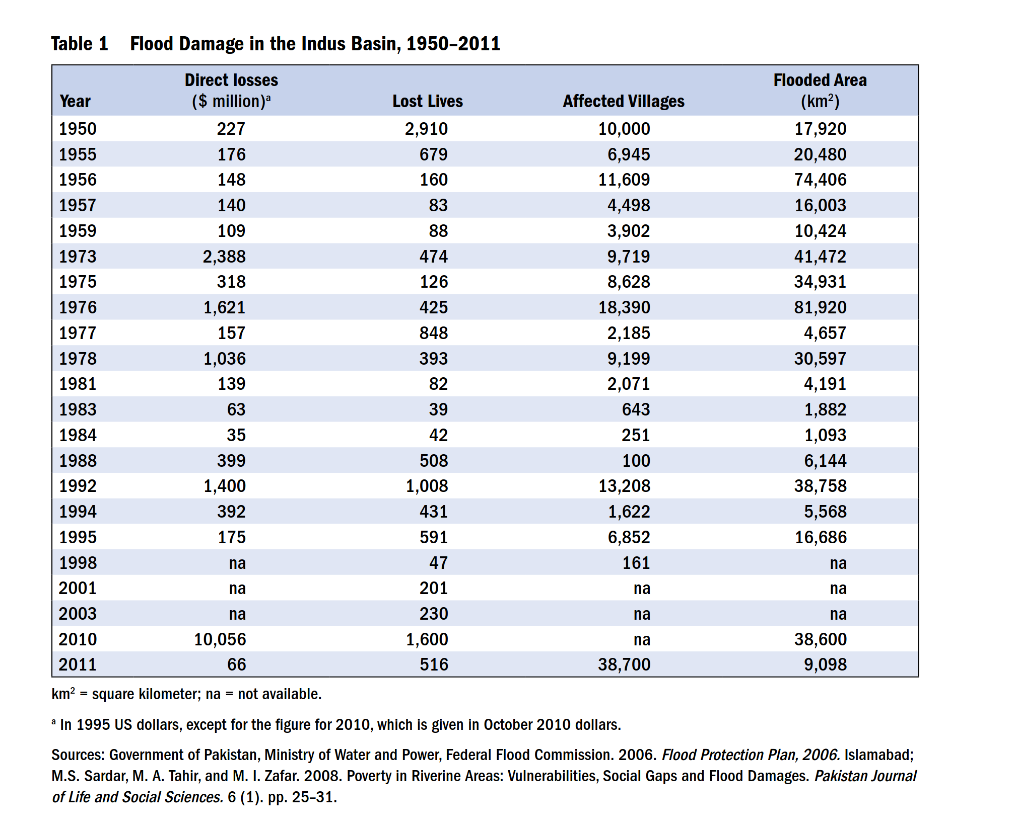
Source 4: Flood Damage Table

Historical Question:
On April 22, 2025, militants opened fire on a resort in the Baisaran valley in Kashmir, a disputed territory between India and Pakistan. 25 Indians and 1 Nepalese person were killed. A group calling themselves the “Kashmir Resistance” claimed responsibility for the attach. India accuses Pakistan of tolerating or supporting such militant groups. India and Pakistan have sent troops to the Kashmir region and they are firing on each other on a daily basis. India suspended the Indus Water Treaty with Pakistan on April 24.
What are the primary historical forces that shape our understanding of this suspension of the Indus Water Treaty? How serious is this suspension to the two countries, based on the evidence you’ve reviewed today?
Source Citations: https://www.adb.org/sites/default/files/publication/30431/indus-basin-floods.pdf
Chakraborty, Ranjani. “The Disastrous Redesign of Pakistan’s Rivers.” Vox, February 7, 2023. https://www.vox.com/videos/2023/2/7/23589769/pakistan-rivers-flooding-colonialism-engineering.
Jentoft-Nilsen, Marit. “NASA Scientific Visualization Studio | 2010 Indus Floods.” NASA Scientific Visualization Studio, March 28, 2013. https://svs.gsfc.nasa.gov/30039.

